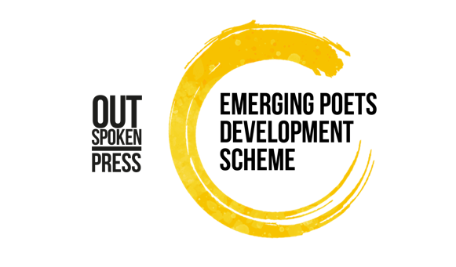
Emerging Poets Development Scheme
Eligibility Criteria

1. Applications are open to writers aged 18+ who live in the UK. Successful applicants will be asked to provide proof of address.

2. If you are currently or are about to be enrolled in a graduate or postgraduate creative writing programme (BA, MA or PhD) you are not eligible to apply. If you have completed a BA, MA or PhD in creative writing in the last two years, you are also not eligible to apply.

3. If you are part of a longer-term development programme during the application window and programme activity (e.g. Jerwood Arvon Mentoring scheme, Penguin Random House Write Now, Faber Academy, London Libraries Emerging Writers scheme etc) you are not eligible to apply.

4. Applicants should be Emerging. We define this as meaning:
a. You do not currently have a literary agent representing you;
b. You have not previously published a full-length collection of poetry;
c. Previously self-published writers can apply with a currently unpublished work.

5. If you are offered a contract to sign up with an agent and/or publishing contract prior to the commencement of the programme (i.e. during the application and judging process), you are ineligible for the Scheme.

6. Judges, their close family members, employees or trustees of Out-Spoken Press, Out-Spoken, Spread the Word, New Writing North or our major supporter Arts Council England are not eligible to apply.

Please also read the Scheme Terms and Conditions before applying.
If you have a question, first read the FAQs.
If your question is not answered through the FAQs, please contact Patricia Ferguson on press@outspokenldn.com

Out-Spoken Press, December 2022

